#*include* <iostream>

#*include* <conio.h>

using namespace std;

*main*()

{

    int num1, num2;

    cout *<<* "Enter First Number: ";

    cin *>>* num1;

    cout *<<* "Enter Second Number: ";

    cin *>>* num2;

    cout *<<* "The sum of two number is: " *<<* (num1 + num2);

*getch*();

}

Output:

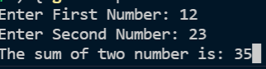

#*include* <iostream>

#*include* <conio.h>

#*include* <iomanip>

using namespace std;

*main*()

{

    int firstNum, secondNum;

    float multiply, add, subtract, modulus, firstFloat, secondFloat;

    float divide;

    cout *<<* "Input First Number: ";

    cin *>>* firstNum;

    cout *<<* "Input Second Number: ";

    cin *>>* secondNum;

    firstFloat = firstNum;

    secondFloat = secondNum;

    multiply = firstNum \* secondNum;

    add = firstNum + secondNum;

    subtract = firstNum - secondNum;

    divide = firstFloat / secondFloat;

    modulus = firstNum % secondNum;

    cout *<<* "Multiplication:\t" *<<* multiply

*<<* "\nAddition:\t" *<<* add

*<<* "\nSubtraction:\t" *<<* subtract

*<<* *setprecision*(2) *<<* *fixed*

*<<* "\nDivision:\t" *<<* divide

*<<* *setprecision*(0) *<<* *fixed*

*<<* "\nModulus:\t" *<<* modulus;

*getch*();

}

Output:

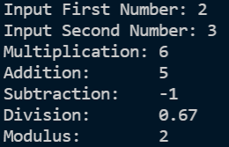

#*include* <iostream>

#*include* <conio.h>

using namespace std;

*main*()

{

    float speed, dist, time;

    cout *<<* "Enter distance in meters: ";

    cin *>>* dist;

    cout *<<* "Enter time in seconds: ";

    cin *>>* time;

    speed = dist / time;

    cout *<<* "The speed is " *<<* speed *<<* " meters per second";

*getch*();

}

Output:

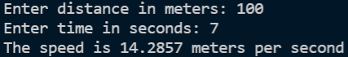

#*include* <iostream>

#*include* <conio.h>

using namespace std;

*main*()

{

    char word1[20], word2[20];

*puts*("Enter a first word: ");

*gets*(word1);

*puts*("Enter a second word: ");

*gets*(word2);

*puts*("You entered");

*puts*(word1);

*puts*("and");

*puts*(word2);

*getch*();

}

Output:

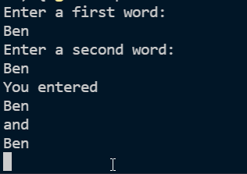

#*include* <iostream>

#*include* <conio.h>

using namespace std;

*main*()

{

    float userUnit, centimeterConvert, meterConvert;

    cout *<<* "Enter a unit of inch that will be converted to meter: ";

    cin *>>* userUnit;

    centimeterConvert = userUnit \* 2.54;

    meterConvert = centimeterConvert / 100;

    cout *<<* "\n\nThe " *<<* userUnit *<<* " inch(es) is equivalent to " *<<* meterConvert *<<* " meter(s).";

*getch*();

}

Output:

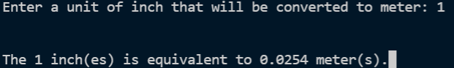

#*include* <iostream>

#*include* <conio.h>

using namespace std;

*main*()

{

    int userUnit, dayConvert, hourConvert, minutesConvert;

    cout *<<* "Enter a year that will be converted to minutes: ";

    cin *>>* userUnit;

    dayConvert = userUnit \* 365;

    hourConvert = dayConvert \* 24;

    minutesConvert = hourConvert \* 60;

    cout *<<* "\n\n"

*<<* userUnit *<<* " Year is equivalent to " *<<* minutesConvert *<<* " minutes";

*getch*();

}

Output:

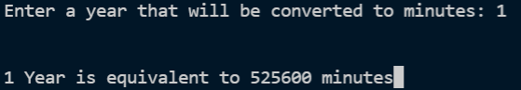

#*include* <iostream>

#*include* <conio.h>

using namespace std;

*main*()

{

    float firstNum, secondNum, thirdNum, sum, average;

    cout *<<* "Enter three numbers: ";

    cin *>>* firstNum;

    cin *>>* secondNum;

    cin *>>* thirdNum;

    sum = firstNum + secondNum + thirdNum;

    average = sum / 3;

    cout *<<* "\n\nThe sum is " *<<* sum *<<* " and the average is " *<<* average;

*getch*();

}

Output:

